SDC ANNUAL REPORT ON HPMP FOR 2018
Project Title: Hydro chlorofluorocarbon Phase-out Management Plan (HPMP)
Name of IP: EPA |  |  |  | Reporting Date: January – December 2018
Date: 18TH DECEMBER 2018
- RESULTS PERFORMANCE/ACHIEVEMENTS
Project Results  State project results (outcomes of Output from approved project document or work plan) | Indicators  The project outcome or output indicators as stated in the M&E Framework and/or AWP |  | Target  Targets agreed by project team on each indicator | Update on Results  A brief analysis on any relevant changes pertaining to the outcome or output achieved with respect to targets | Comments
Outcomes
Establishment and Operation of Refrigeration Centers of Excellence | Number of training centers established. |  | 3 centres of excellence established to train refrigeration technicians | 3 centres of excellence were established at the Accra technical Training Centre, Kumasi Technical Institute and the Takoradi Technical Institute to provide technical training services to refrigeration technicians in the northern and southern sectors of Ghana. These centers are prepared as dedicated space to accommodate the tools and equipment to be used for training students and practitioners in both formal and informal sectors of the refrigeration industry. This is to ensure that practitioners undergo necessary training in order to be familiar with the technology involving the use of hydrocarbons.  After the inauguration of the two centres in January 2018, about 400 refrigeration technicians were trained in this reporting period on best techniques in refrigeration and the role they have to play to preserve the ozone layer. This contributes to national efforts to remain compliant with the Montreal Protocol.
Refrigerant Recovery Recycling Project (RRRP) | Number of HCHC 22 ACs converted to HC 290 |  | At least 500 units of ACs running on HCFC 22 converted to HC 290 | The eleven (11) RRR centres who underwent training successfully converted 870 units of ACs to run on HC 290. The converted ACs to run on HC290 have all been verified.  This programme has contributed to national activities to phase out the use of HCFCSs and has built adequate capacity ad the regional and district level to operate refrigeration operation using best available techniques.
Data on conversions of ACs to Hydrocarbon (HC290) from January 2018 – December 2018
YEARS |  | TOTAL AIR CONDITIONERS CONVERTED |  |  | QUANTITIES OF GASES RECOVERED (kg)
2013 |  | 422 |  |  | 962.5
2014 |  | 814 |  |  | 2036.29
2015 |  | 1105 |  |  | 2858.88
2016 |  | 2630 |  |  | 5158.19
2017 |  | 4009 |  |  | 6935.61
2018 |  | 870 |  |  | 1584.62
TOTAL |  | 9850 |  |  | 19536.09
- GENDER SPECIFIC RESULTS [Please report specific gender disaggregated results]

The Refrigeration industry is highly dominated by males however there are few females who are practicing or studying the trade in technical institutions, the Polytechnic as well as in individuals workshops

- PROJECT IMPLEMENTATION CHALLENGES [Observed or experienced challenges that are generic, related or not related to any specific output, which have or could affect the project implementation and propose a way forward]
- There are a lot of technicians who are ignorant about the HC290 conversion technology because it’s now being transferred to Africa.
- The tools and equipment distributed for the conversions are inadequate. It therefore limits the number of conversions that are done in a period of time.
- Improper records keeping by the cold store operatives makes it difficult to fill the incentive applications forms.

- LESSONS LEARNED AND OPPORTUNITIES [Please describe new understanding or insights gained from project activities that can contribute to improving project implementation and future project design]
- People are now becoming aware of HC ACs and their benefits offering a potential for wider market penetration
- RECOMMENDATIONS AND PROPOSED ACTION [Actions on any matter related to outcome, progress of outputs and corrective measure taken or to be taken with responsibilities time time]
- There should be books and literature on the hydrocarbon technology so that practitioners can read and enrich their knowledge
- Practitioners can also go to the internet to browse for further information by taking them through computer training, senior technicians and the junior ones must all be taken through computer training.
- Non-certified practitioners should not be allowed to apply the trade or allowed to undertake or handle any hydrocarbon application
- Future projects must include purchase of tools and equipment for the technicians. This can enable them deliver quality output.
- The seats at the ATTC Centre of Excellence must be increased to give room for more participants.
- Generator of IOKVA capacity should be purchased to sustain the power supply to the centre.
- Conversion of A/C units to run on HC290 must be continued to enable Ghana reduce her dependency on HCFC 22 to meet the MP levels
- Capacity building in the form of training and seminar and workshops should be encouraged to make practitioners, importers, distributions and the general public be abreast with new technological innovations from the advanced countries
- Upscale the training of more technicians in the HC conversion to prevent the temptation to engage in it whiles they don’t have the requisite expertise

- KEY ACTIVITIES FOR 2018 [Please outline key activities planned for 2018]
- Refrigerant Recovery and Recycling Project.
- Training and retraining of refrigeration technicians and certification.
- Continuous training of Customs Officers from Ghana Revenue Authority.
- Purchasing of refrigeration test boards and generator sets for the centres.
- Procure a consultant to draft stage 2 HPMP and the certification modules.
- Monitoring of all the HPMP subprojects.

ATTACHMENTS:

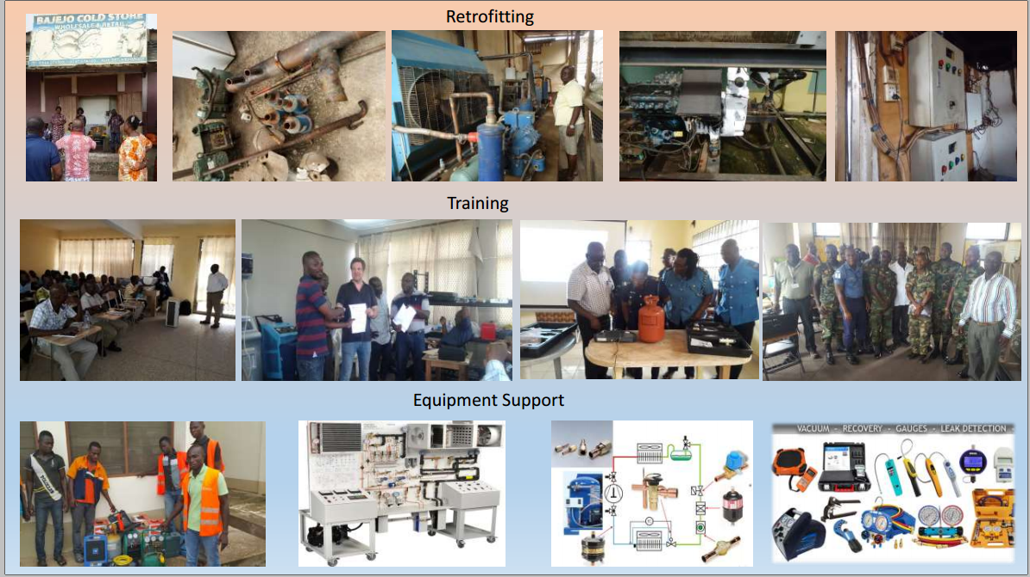

Pictures from training workshops at TTI & KTI

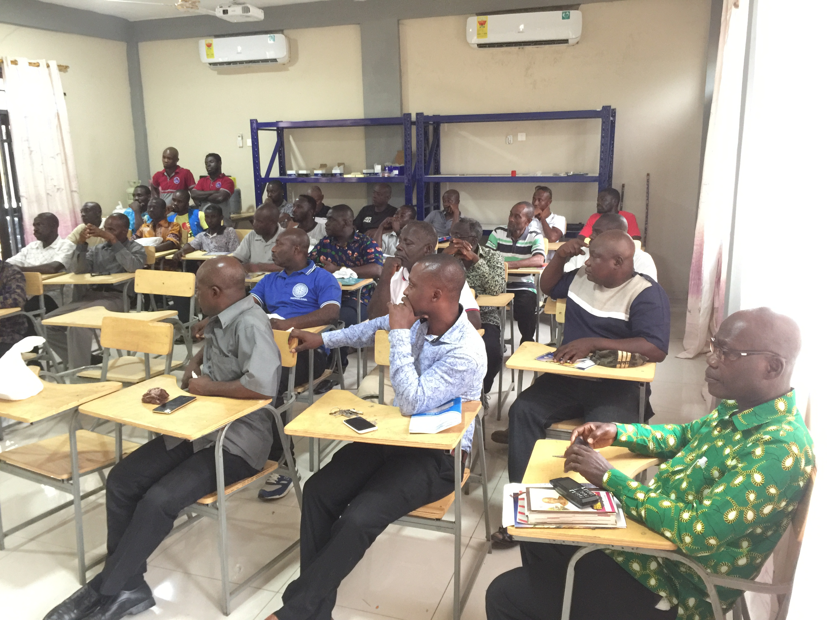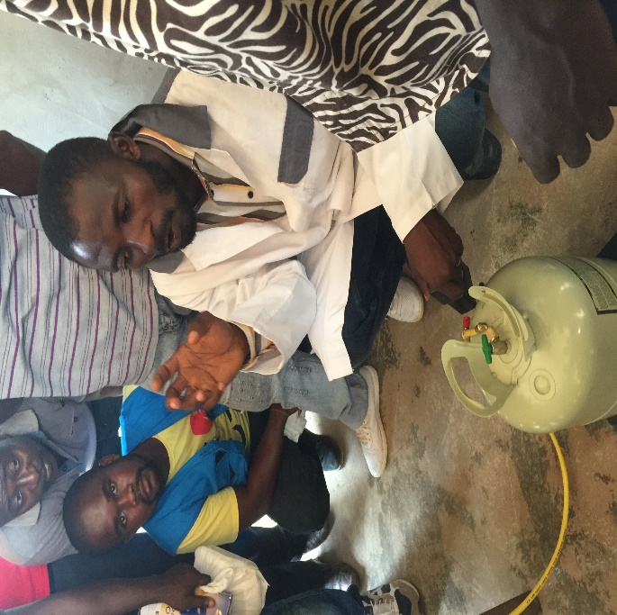

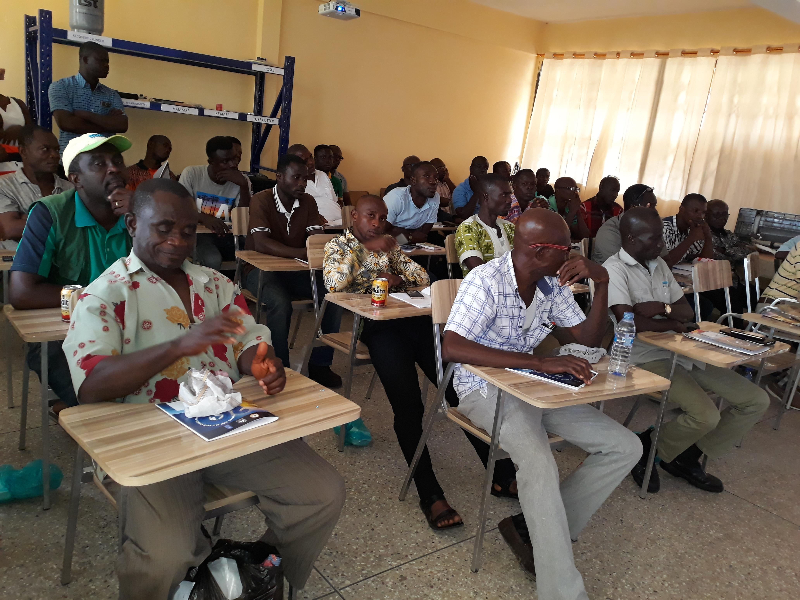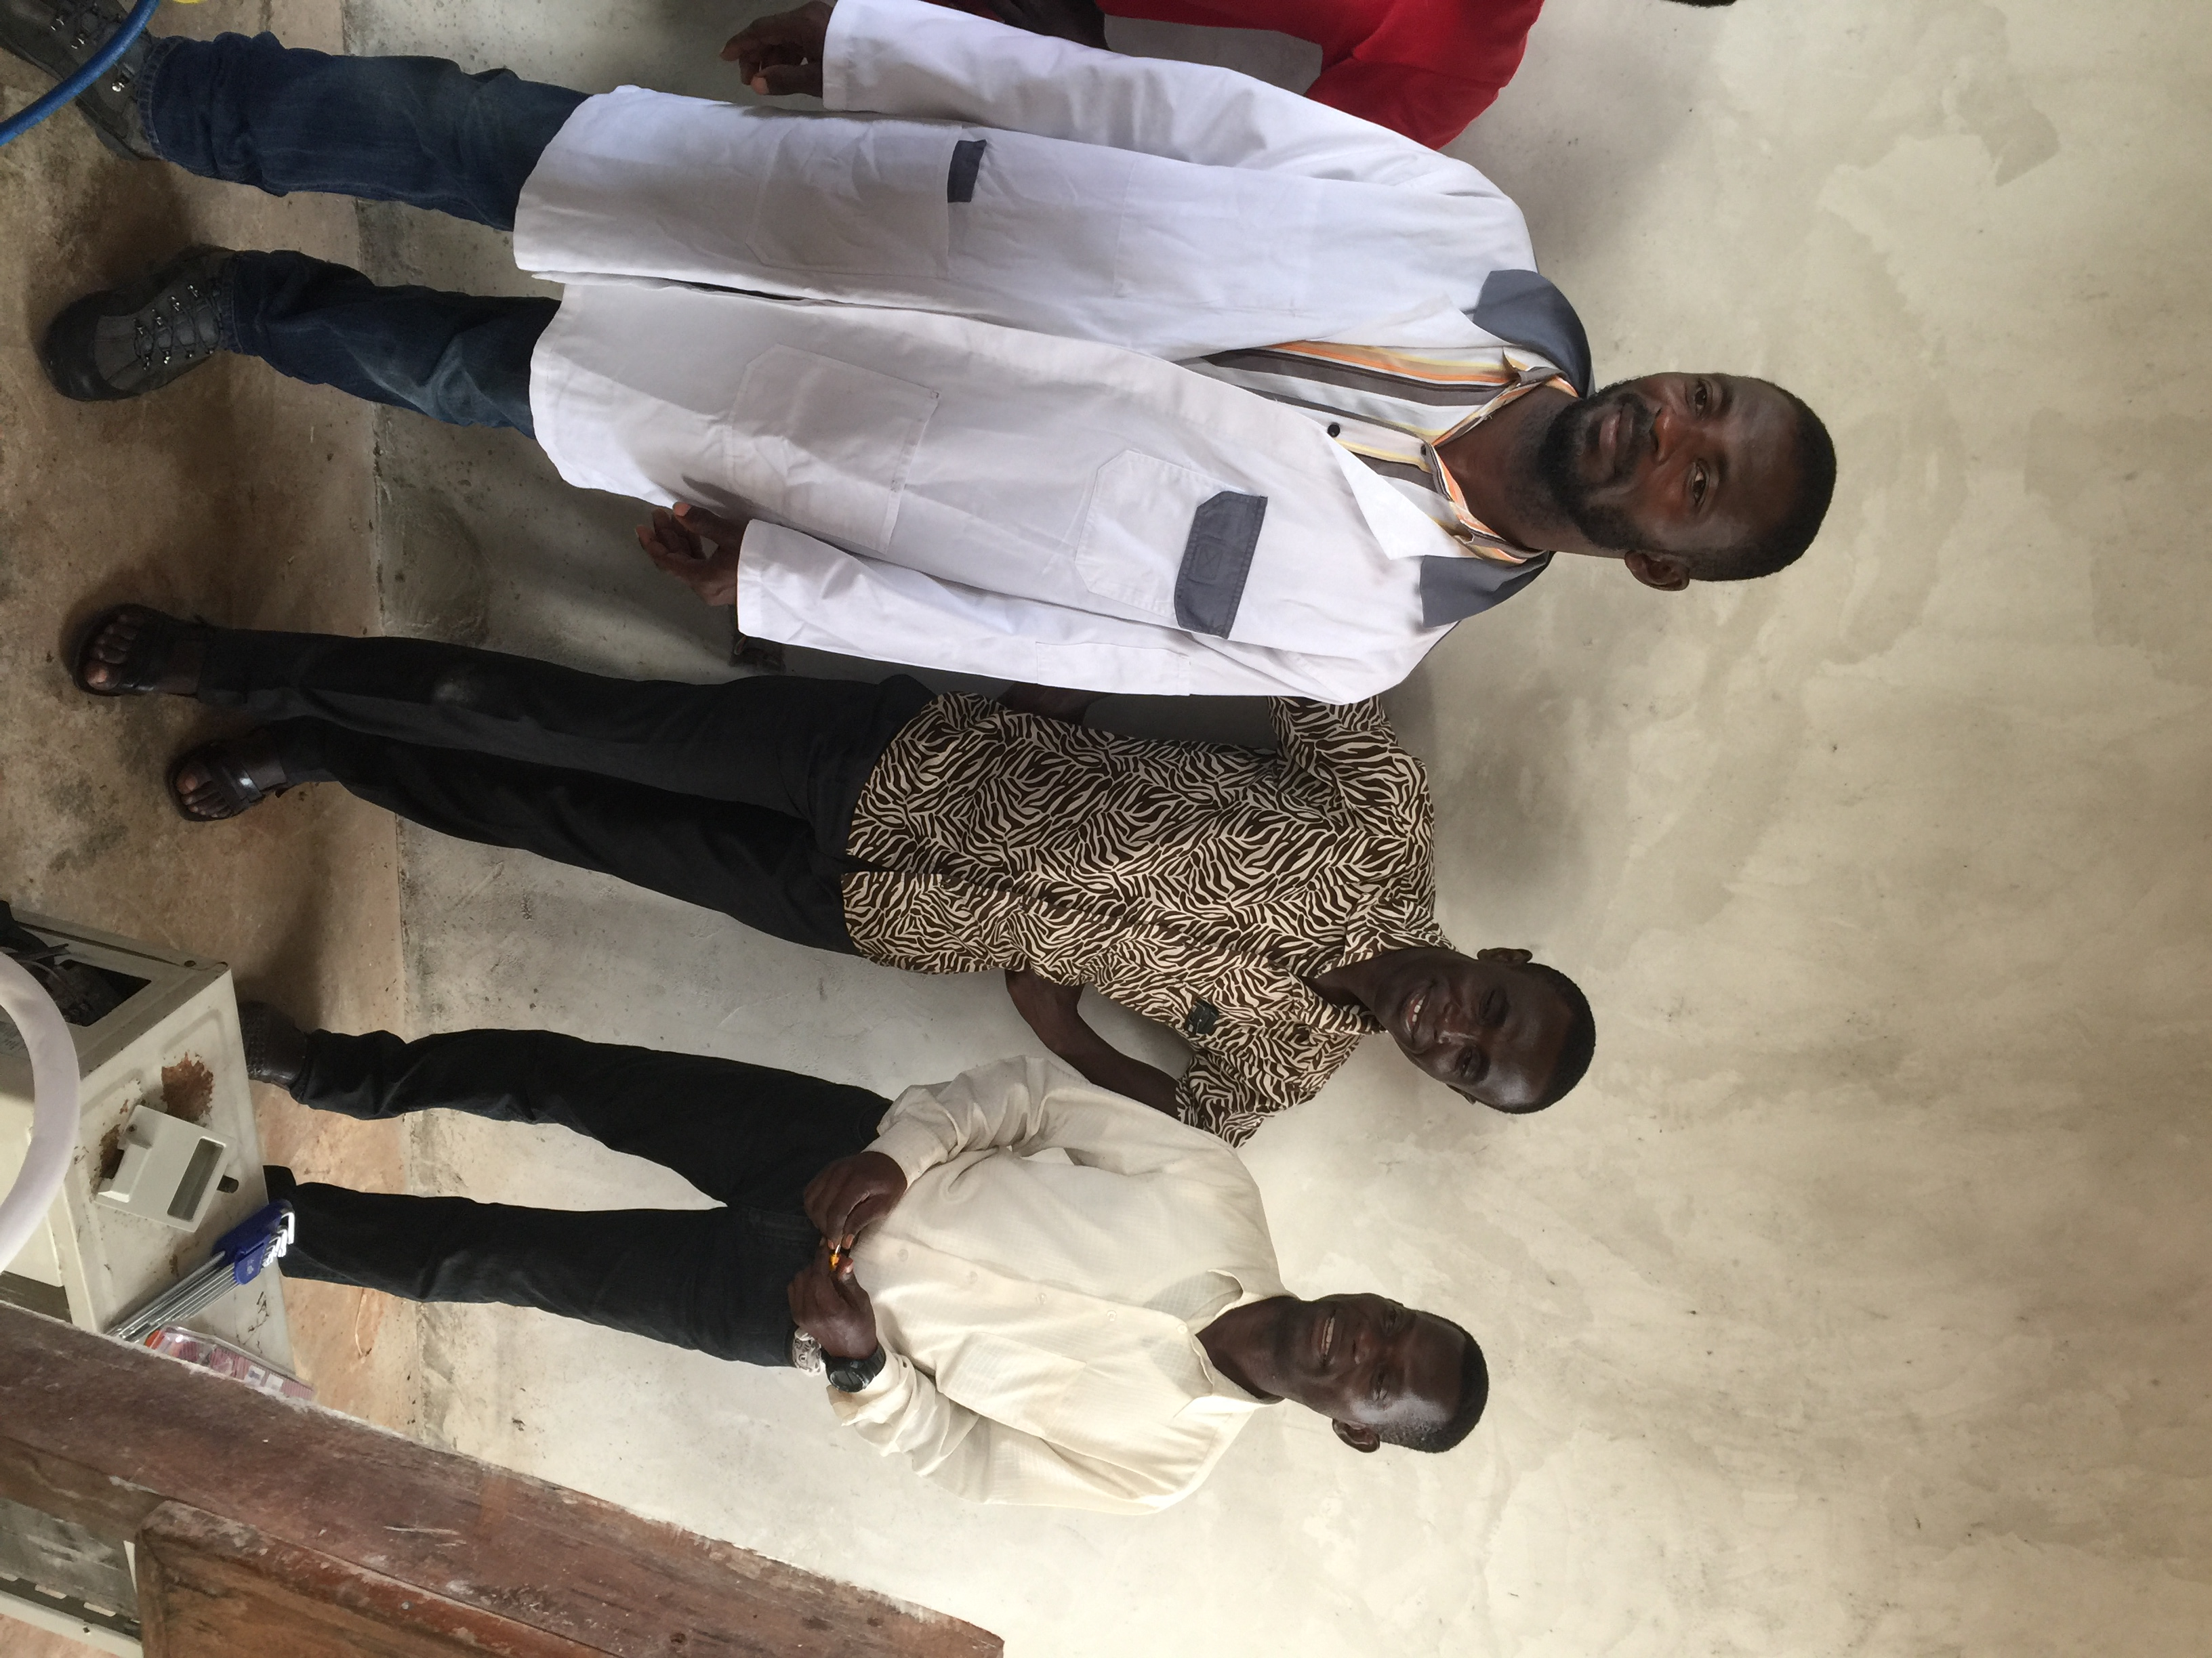
Tutors manning the 3 Centres of Excellence who have been trained in Germany kind courtesy of GIZ.

